**OUTPUT**

Exercise 1: Control Structures

Scenario 1:

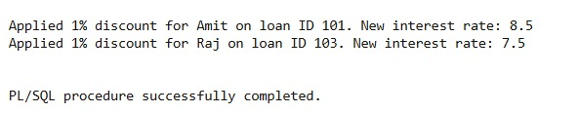

Scenario 2:

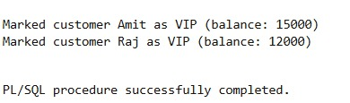

Scenario 3:

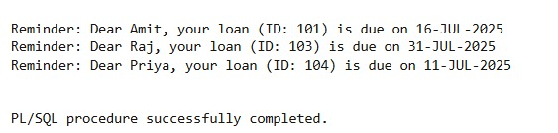

Exercise 3: Stored Procedures

Scenario 1:

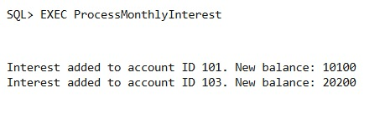

Scenario 2:

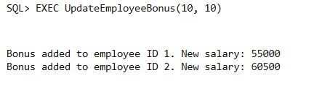

Scenario 3:

